Distance Matrix Implementation for Route Optimization

### **Introduction**

The distance matrix is a crucial component in the optimization of waste collection routes. It represents the shortest and most efficient paths between multiple points, which in this project are the locations of waste bins. This document outlines the methodology used to generate and utilize the distance matrix, its role in route optimization, and its impact on the operational efficiency of waste collection services.

### **Distance Matrix Definition**

A distance matrix is a two-dimensional array where each element $\left(i,j\right)$ represents the distance from point $\left(i\right)$ to point $\left(j\right)$. When considering this project, each point corresponds to a bin location, and the distance is typically measured in terms of travel distance between these points.

### **Methodology**

* **Data Collection**

The geographical coordinates (latitude and longitude) of each bin are collected from the data set provided by **City of Melbourne Open Data** and the data set was cleaned in the python environment using Jupiter notebook.

**The below image chows the cleaned data set.**

* **Calculation**

The distance matrix is computed using the **cdist** function from the **SciPy** library, which calculates the distance between each pair of points in the dataset. The metric used is **Euclidean**, which computes the straight-line distance between points in a Euclidean plane. The formula used is:

$$d\left(i,j\right)= \sqrt{{(x_{i}-x_{j})}^{2}+{(y_{i}-y_{j})}^{2}}$$

$i$ Were $(x_{i}-y_{i})$ and $(x_{j}-y_{j})$ are the geographical coordinates of bins $i$ and $j$ respectively.

***The below image shows the code used.***

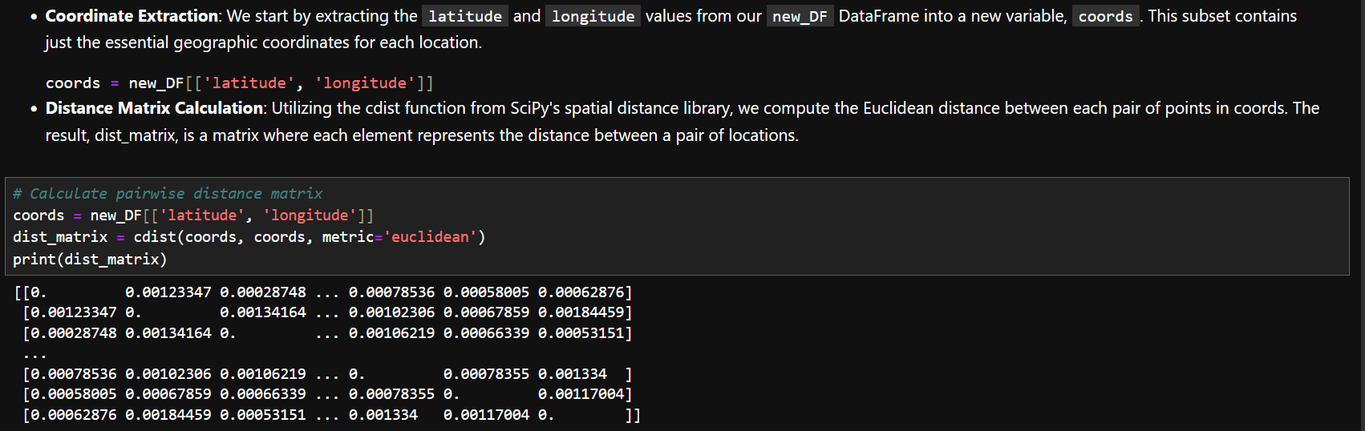

​**Integration in Route Optimization**

### The distance matrix serves as the input for the route optimization algorithm. The algorithm iteratively selects the shortest distances from the matrix to determine the optimal route that minimizes travel time and maximizes the efficiency of the collection process.

### **Usage in the Project**

* **Route Calculation:** Once the distance matrix is calculated, it is used to identify the nearest next bin to visit, starting from the bin with the highest fill level. This approach ensures that bins most in need of service are prioritized, while also minimizing the travel distance between stops.

**Code:**

* **Initializing the Route**: The route list is initialized with the starting point, chosen as the first location in our prioritized list. This represents the location with the highest fill level.

**Code:**

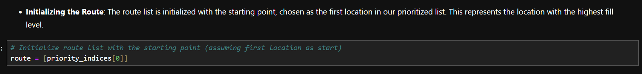

* **Determine Next Stop:**To determine the next stop, we follow a simple heuristic: from the current location, move to the nearest unvisited location. For each subsequent location:

1. Calculate the distances from the last visited location to all others using the precomputed distance matrix, **dist_matrix.**
2. Temporarily set the distance to already visited locations to infinity to exclude them from consideration.
3. Identify the next stop as the location with the minimum distance to the last visited location. This location is then added to the route.

* This methodical approach to route optimization, prioritizing bins by their necessity for service (based on fill levels) and sequentially choosing the next nearest location, significantly enhances efficiency. It not only ensures the most critical bins are attended to promptly but also minimizes the operational costs associated with travel distances.

**Code:**

### **Benefits**

* **Efficiency:** Significantly reduces the computational complexity compared to calculating distances on-the-fly during optimization.
* **Scalability:** Easily scales with increasing numbers of bins as only the matrix dimensions increase.
* **Accuracy:** Provides a reliable and consistent basis for route planning decisions.

### **Conclusion**

The distance matrix is a powerful tool in the arsenal of route optimization for waste management. By pre-calculating distances between all relevant points, it allows for rapid, dynamic adjustments to routes based on real-time data on bin fill levels. This methodology not only improves the efficiency of waste collection but also contributes to environmental sustainability by reducing unnecessary fuel consumption.

## Author

Sachitha 2024.v1